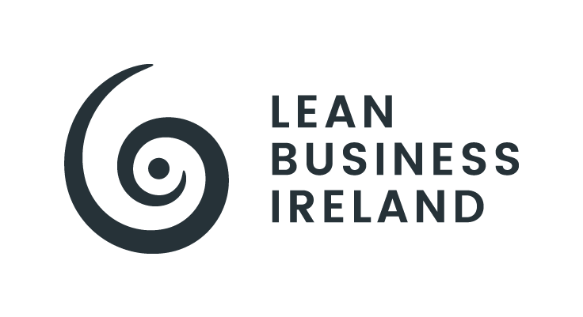

Lean Business Ireland Awards

Category: | Small Lean Business Of The Year
Entrant Organisation:
Size Organisation: | Small
Entry Overview (100-150 words):

Entrant Submission
CRITERIA & WEIGHTING | ENTRANT CONTENT (entrants should ensure that content is proportional to the respective criteria weighting)
LEAN STRATEGY, JOURNEY, IMPROVEMENTS (20%: half-to-1 page)
- Evidence of understanding of Why Lean, and it being a Journey.
- Evidence of understanding of Lean being a principles-driven approach.
- Evidence of understanding of Value, Waste, and Voice of Customer.
- Evidence of understanding of Lean Thinking, Tools, and Techniques.
- Evidence of appreciation for results-orientation vis-a-vis annualised productivity improvements (value created, efficiency gains, cost savings).
- Evidence of understanding of the need for continual learning and continuous improvement.

CRITERIA & WEIGHTING | ENTRANT CONTENT (entrants should ensure that content is proportional to the respective criteria weighting)
OPERATIONALISATION & RESULTS (55%: 2-3 pages)
- Evidence of a business-wide awareness of Lean Thinking, Value, Waste, etc.
- Evidence of efforts to develop a Problem-Solving Culture.
- Evidence of efforts to develop a pipeline of Improvement Initiatives.
- Evidence of efforts to implement Process Flow and Standardisation.
- Evidence of efforts around Lean Leadership, Employee Engagement, and Mentoring and Coaching.
- Evidence of efforts to build employee capability.
- Evidence of efforts to advance structured approaches, scientific thinking, visual management, CI meetings, etc.

CRITERIA & WEIGHTING | ENTRANT CONTENT (entrants should ensure that content is proportional to the respective criteria weighting)
FUTURE PLANs & CI (25%: half-to-1 page)
- Future focus and next steps.
- Strategic planning and integration.
- Future CI projects identified.
- Ongoing knowledge management, learning, upskilling, and capability development plans.
- Clear prioritisation on People and Culture.

