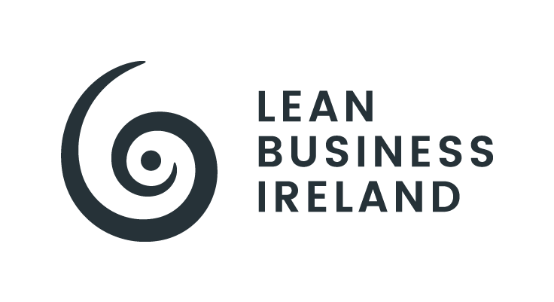

Lean Business Ireland Awards

Category: | Large Lean Business Of The Year
Entrant Organisation:
Size Organisation: | Large
Entry Overview (100-150 words):

Entrant Submission
CRITERIA & WEIGHTING | ENTRANT CONTENT (entrants should ensure that content is proportional to the respective criteria weighting)
LEAN STRATEGY DEVELOPMENT & LEADERSHIP (10%: half-page)
- Evidence of a strategic organisation and enterprise-wide approach to excellence.
- Evidence of Lean & CI Strategy alignment with recognised global best practices and frameworks.
- Evidence of strategic alignment of business systems and KPIs, and of purpose, people, and processes.
- Evidence of strategic emphasis on formative design and implementation support; and on stakeholder engagement, prioritisation, and analysis: most critically the Voice of Customer, both internal and external.
- Evidence of senior leadership team (SLT) buy-in and support; and vision and mission developed and clearly communicated enterprise-wide and with all stakeholders.

CRITERIA & WEIGHTING | ENTRANT CONTENT (entrants should ensure that content is proportional to the respective criteria weighting)
LEAN STRATEGY DEPLOYMENT (10%: half-page)
- Evidence of Hoshin Kanri thinking and practice.
- Evidence of Customer and Value focus.
- Evidence of effective Management and CI systems in place with aligned metrics and oriented to advancing and sustaining a culture of excellence.
- Evidence of effective People Development systems, and Knowledge and Learning systems, in place and aligned to the core strategy.
- Evidence of effective Visual Management systems across the organisation/enterprise, along with measurable progress reported across all departments/units/levels.
- Evidence of Leadership systems and Leader Standard Work focused on culture, behaviours, and respect for people and the work.
- Evidence of systemic and holistic deployment that is mindful of and positive towards the planet and wider community and society.

CRITERIA & WEIGHTING | ENTRANT CONTENT (entrants should ensure that content is proportional to the respective criteria weighting)
OPERATIONALISATION & RESULTS (55%: 2-3 pages)
- Evidence of an Enterprise-wide focus; Results-orientation; CI/Kaizen Projects; Scientific Thinking; Measurement, Analysis, and Reporting; Knowledge Management and Learning; and Respect and Recognition systems.
- Evidence of clearly defined Behavioural Standards linked to the core business and performance, as well as overall culture.
- Evidence of Lean Leadership, Employee Engagement, and Mentoring and Coaching.
- Evidence of active development of managers, supervisors, team leads, administrators, and shop-floor associates/operatives that is relevant to their work and, ideally, driven by their own 'pull' for their ongoing personal and professional development.
- Evidence of defined time and processes to capture ideas and opportunities for improvement, along with defined systems of work and a constant focus on the simplification of work and standardisation.
- Evidence of Value Stream analysis.
- Evidence of fulfilment on the Customer and Value focus.

CRITERIA & WEIGHTING | ENTRANT CONTENT (entrants should ensure that content is proportional to the respective criteria weighting)
FUTURE PLANNING (25%: 1-page)
- Evidence of a clear and sustainable CI strategy.
- Evidence of a balanced approach to the Socio and the Technical.
- Evidence of balanced and systemic integration of next-generation technologies and digitalisation.
- Evidence of alignment with and fulfilment of ESG/Sustainability/Circular Economy principles and priorities.
- Evidence of an ambitious and ongoing capability development and learning organisation strategy.

